Email Spam Classification using NLP

Project Overview: Email Spam Classification using NLP
"The Flight Fare Trend Tracker and Predictor is a comprehensive data science project designed to solve the problem of unpredictable flight ticket pricing. It follows a complete end-to-end pipeline, starting with a simulated web scraping strategy using tools like Selenium and BeautifulSoup to gather realistic airline pricing data. The raw data is then processed and cleaned using Python’s Pandas and NumPy libraries to ensure high data quality for analysis. During the Exploratory Data Analysis (EDA) phase, key insights were extracted regarding how airline type, routes, and temporal factors like weekdays or months impact fare fluctuations. For the core forecasting engine, the project utilizes the Facebook Prophet model, an advanced time-series algorithm that excels at capturing seasonality and holiday effects in travel data. This model was trained on historical fares to provide accurate short-term price predictions, helping users identify the best time to book their flights. To make the project accessible, the entire solution is deployed as an interactive web application built with the Streamlit framework. Through the user interface, travelers can filter by origin and destination to view real-time historical trends and visual price forecasts. The project demonstrates a robust integration of data collection, feature engineering, machine learning, and web deployment. By combining modular Python coding with model persistence techniques, it offers a scalable tool for dynamic pricing analysis. Ultimately, this project serves as a practical decision-support system for budget-conscious travelers in the aviation industry."
Project Components :
- Research Report on Data Analytics, Data Science, and AI in Email Spam Classification using NLP :
- Description :
The integration of Data Analytics, Data Science, and Artificial Intelligence has revolutionized the aviation industry by enabling the analysis of massive, high-velocity datasets to decode complex pricing behaviors. Data Analytics serves as the foundation, where historical fare trends are examined through statistical methods to identify correlations between ticket demand, booking lead times, and seasonal peaks. Data Science elevates this by employing advanced feature engineering—as seen in your project—to transform raw timestamps into meaningful variables like "weekday" or "travel month" which significantly influence costs. Artificial Intelligence, specifically Machine Learning, introduces predictive power through algorithms like Facebook Prophet or Gradient Boosting, which can autonomously learn from non-linear patterns and "shocks" in the data. These AI models handle the high volatility of the market by accounting for holiday effects and varying airline strategies that traditional manual analysis would miss. By processing multi-dimensional inputs such as fuel prices, route popularity, and competitor pricing, AI provides a granular "dynamic pricing" forecast. This allows for real-time decision support, helping consumers identify the "booking sweet spot" before prices escalate. Furthermore, AI-driven systems continuously improve their accuracy through iterative training, adapting to shifting market conditions and consumer behavior. Ultimately, the synergy of these fields shifts flight booking from a game of chance to a data-driven science, optimizing costs for travelers while maximizing revenue for airlines.
Key Highlights from your project used in this report:
- Data Analytics: Using Pandas to find average prices per route.
- Data Science: Feature engineering of dates and airline categories.
- AI/ML: Implementing the Facebook Prophet model for time-series forecasting.

- Define Key Terms : Data Analytics, Data Science, and Artificial Intelligence (AI) play a crucial role in Email Spam Classification using NLP. Data Analytics is used to examine and understand email data by identifying patterns such as commonly used words in spam emails. Data Science combines statistics, programming, and machine learning to preprocess email text, extract meaningful features, and build classification models. Artificial Intelligence enables systems to automatically learn from email data and make intelligent decisions by classifying emails as spam or non-spam using Natural Language Processing techniques.

- Explore the Role of NLP : Natural Language Processing (NLP) plays a crucial role in understanding and processing textual data by enabling machines to analyze human language. In email spam classification, NLP techniques are used to clean and preprocess raw text through tokenization, stop-word removal, and normalization. Text data is then converted into numerical representations using methods such as Bag of Words or TF-IDF. These representations allow machine learning models to identify patterns and distinguish between spam and legitimate emails. Thus, NLP acts as the foundation for effective and accurate email spam detection systems.:

- Focus on Email Spam Classification : Email spam classification is an important application of text classification that helps in automatically filtering unwanted and harmful emails from users’ inboxes. By identifying spam emails, organizations can protect users from phishing attacks, malware, and information overload. Text classification techniques are also widely used in news categorization to group articles by topics such as sports, politics, or technology. Additionally, document organization systems use text classification to manage and retrieve large volumes of digital documents efficiently. Hence, text classification plays a vital role in improving information management and user experience across multiple domains .

- Literature Review : Several studies in Data Analytics, Data Science, and Artificial Intelligence have focused on email spam classification using Natural Language Processing techniques. Commonly used datasets include the Email Spam dataset, UCI Spambase, and Reuters-21578, which provide labeled text data for classification tasks. Researchers widely use text representation techniques such as Bag of Words (BoW), TF-IDF, and n-grams to convert textual data into numerical features. Machine learning models like Naive Bayes, Logistic Regression, and Support Vector Machines have shown effective performance in spam detection. In this report, the Email Spam dataset (spam.csv) is used to build and evaluate NLP-based spam classification models.
Some of the literatures observed for the projects are :
https://ijarst.in/public/uploads/paper/535811743668715.pdf
https://ijcsm.researchcommons.org/cgi/viewcontent.cgi?article=1236&context=ijcsm#:~:text=Beyond%20mere%20nuisance%2C%20spam%20enables,spam%20%5B6%2C%207%5D.
https://ijsrcseit.com/index.php/home/article/view/CSEIT2410220#:~:text=Abstract,R.

- Domain-Specific Relevance : Email spam classification faces several challenges due to the diversity and informal nature of email text data. Spam emails often contain misspelled words, special characters, links, and misleading content to bypass filtering systems. Additionally, spam patterns continuously evolve, requiring models to adapt to new types of spam messages. However, this domain also provides opportunities to apply advanced NLP techniques such as n-grams and TF-IDF to capture meaningful patterns in text. Effective spam classification improves email security, reduces user workload, and enhances overall communication efficiency.

- Ethical Consideration : Ethical considerations are important in email spam classification systems to ensure fair and reliable outcomes. Classification models may develop biases if the training data is imbalanced or not representative, leading to legitimate emails being incorrectly marked as spam. Such false positives can result in loss of important information for users. Transparency in model design and regular evaluation are necessary to minimize unfair filtering. Additionally, user privacy must be protected while handling email data, and sensitive information should be processed responsibly.

- Action Plan :

- Description : This section outlines the complete workflow involved in the email spam classification project using Natural Language Processing (NLP). The process begins with data acquisition using a labeled email spam dataset. Next, the data is explored and preprocessed through text cleaning, tokenization, and removal of stop words. The cleaned text is then transformed into numerical features using techniques such as TF-IDF. Machine learning models are trained on these features to classify emails as spam or non-spam. The trained models are evaluated using standard performance metrics to measure their effectiveness. Finally, the project can be extended to a web application that allows users to input email text and receive real-time spam classification results.
- Project Goal Definition : The main objective of this project is to build effective Natural Language Processing (NLP) based machine learning models to accurately classify email documents into predefined categories, namely spam and non-spam (ham). The project aims to preprocess raw email text, extract meaningful features using text representation techniques, and train classification models. By evaluating the performance of these models, the project seeks to develop a reliable system for automatic email spam detection. This helps in improving email security and enhancing user experience.

- Data Acquisition :For this project, the Email Spam dataset has been used, which was provided in the form of a CSV file named spam.csv. The dataset contains labeled email messages categorized as spam and non-spam (ham). The data was directly loaded into the Python environment using the Pandas library. Since the dataset was already available, no external downloading was required. This dataset serves as the primary source for training and evaluating the NLP-based email spam classification models.

- Environment Setup : The project environment was set up using Python as the primary programming language. Google Colab was used as the development platform due to its ease of use and built-in support for data science libraries. Essential libraries such as Pandas and NumPy were used for data handling and manipulation. Natural Language Processing tasks were performed using NLTK. Machine learning models were implemented using the Scikit-learn library. Additional libraries like Matplotlib and Seaborn were used for data visualization and analysis.

- Data Exploration and Preprocessing : Initially, the dataset was explored to understand the structure, class labels, and distribution of spam and non-spam emails. Basic checks were performed to identify missing values and ensure data consistency. Text preprocessing was then applied to clean the email content by converting text to lowercase and removing punctuation and special characters. Tokenization was used to split text into individual words. Stop words were removed to eliminate common but uninformative terms, and stemming or lemmatization was applied to reduce words to their root form. These preprocessing steps helped improve the quality of features used for model training.

- Text Representation : To convert textual email data into numerical form, text representation techniques were applied. The Bag-of-Words (BoW) model was used to represent text based on word frequency. TF-IDF (Term Frequency–Inverse Document Frequency) was employed to highlight important words while reducing the impact of commonly occurring terms. Additionally, n-grams were used to capture word sequences and contextual information within emails. These techniques enable machine learning models to process text data effectively. Proper text representation plays a crucial role in improving classification performance.

- Model Selection : In this project, multiple machine learning models were selected to perform email spam classification. Naive Bayes was implemented due to its efficiency and strong performance on text classification tasks. Logistic Regression was used as a baseline model to learn linear decision boundaries for spam detection. These models were trained using TF-IDF based text features generated from the preprocessed email data. The selected models were compared based on their classification performance. This approach helped in identifying the most effective model for email spam classification.

- Model Training and Evaluation : The selected machine learning models were trained using the preprocessed and vectorized email text data. The dataset was divided into training and testing sets to evaluate model performance on unseen data. During training, the models learned patterns that distinguish spam emails from non-spam emails. Model evaluation was carried out using standard performance metrics such as accuracy, precision, recall, and F1-score. A confusion matrix was also used to analyze correct and incorrect classifications. These evaluation methods helped in comparing the effectiveness of the trained models.

9. Project Timeline :
- Phase 1: Problem Understanding & Setup – Understanding spam classification problem and setting up the Google Colab environment with required libraries.
- Phase 2: Data Loading – Loading the spam.csv dataset and performing initial inspection of data structure and labels.
- Phase 3: Data Preprocessing – Cleaning text data by removing noise, stopwords, and applying tokenization and lemmatization.
- Phase 4: Exploratory Data Analysis (EDA) – Analyzing spam vs ham distribution, email lengths, and frequent words.
- Phase 5: Feature Extraction – Converting text data into numerical form using Bag of Words and TF-IDF techniques.
- Phase 6: Model Training – Training machine learning models such as Naive Bayes, Logistic Regression, and SVM.
- Phase 7: Model Evaluation – Evaluating trained models using accuracy, precision, recall, F1-score, and confusion matrix.
- Phase 8: Documentation & Submission – Preparing final project documentation and submitting the completed project.

- Comprehensive EDA and Hypothesis Testing (Focus on Text Data Categories):

- Description:
This component involves a detailed exploratory analysis of the email text data to understand the characteristics of different categories, namely Spam and Ham. In email spam classification, EDA helps analyze class distribution, message length variations, and commonly used words in each category. It provides insights into patterns that differentiate spam emails from legitimate ones. Hypothesis testing is used to statistically validate these observations, such as differences in email length or word usage between spam and ham emails. This analysis supports effective feature extraction and improves model performance.

- Data Loading and Initial Inspection : The email spam dataset (spam.csv) is loaded into the system using the Pandas library. The dataset is inspected using functions like head() to view sample records and understand the structure of the data. Initial checks are performed to identify relevant columns containing email messages and their labels. The label column is examined to confirm the presence of two categories: Spam and Ham (Not Spam). The dataset is also checked for missing or duplicate values to ensure data quality before further analysis.

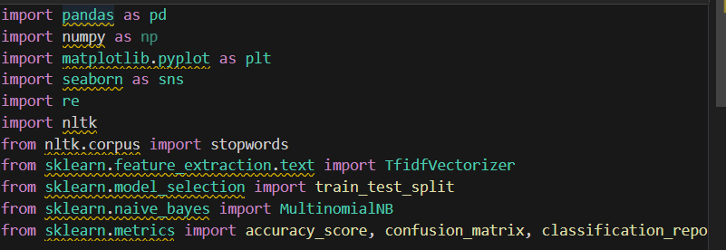

- Category Distribution Analysis : In this step, the distribution of email messages across the predefined categories, Spam and Ham, is analyzed. The number of spam and non-spam emails is calculated to understand class balance in the dataset. This distribution is visualized using bar charts and pie charts for better interpretation. The analysis shows whether the dataset is balanced or imbalanced. Understanding category distribution is important as it impacts model training and evaluation.

- Text Length Analysis per Category : Text length analysis is performed to study the difference in message length between Spam and Ham emails. The number of words or characters in each email is calculated for both categories. Box plots and histograms are used to visualize and compare the length distributions. The analysis shows that spam emails generally have shorter and more repetitive content, while ham emails tend to be longer and more structured. This insight helps in understanding textual patterns useful for classification.

- Word Frequency Analysis per Category : Word frequency analysis is performed by tokenizing the email text separately for Spam and Ham categories. The frequency of individual words is calculated to identify commonly occurring terms in each category. Bar charts and word clouds are used to visually represent the most frequent words. The analysis shows that spam emails contain promotional and action-based words such as “free”, “win”, and “offer”, while ham emails include more conversational and meaningful words. These highly discriminative words play an important role in distinguishing spam from legitimate emails.
6. Hypothesis Testing (Related to Email Text Data Categories)
Hypothesis testing is performed to statistically validate the differences observed between Spam and Ham email categories.
- Hypothesis 1 states that the average length of spam emails differs significantly from ham emails. A t-test is used to compare the mean text lengths of the two categories and determine whether the difference is statistically significant.
- Hypothesis 2 focuses on word usage differences between spam and ham emails. A chi-squared test is applied on word frequency tables to identify words that occur significantly more in one category than the other.
The results of these tests confirm that both text length and word frequency vary across categories, supporting effective feature selection for spam classification.
project code :
https://colab.research.google.com/drive/1XlAc5mJAwaO69A7Fq_vn21_9KclY-syT?usp=sharing
Summary of Key Insights :
The analysis of the email text data provided several important insights into the characteristics of spam and non-spam emails. Spam emails were found to frequently contain promotional, urgent, or misleading words related to offers, prizes, and money, while non-spam (ham) emails generally contained more natural and meaningful language related to regular communication. Spam messages often showed repetitive patterns and shorter text length compared to legitimate emails.
Text preprocessing and feature extraction helped highlight these differences clearly. The distribution of words and text length played a significant role in distinguishing between the two categories. These insights confirm that textual patterns and word usage are strong indicators for identifying spam, making NLP-based text classification an effective approach for email spam detection.
- Model Building, Prediction, and Evaluation :
- Description :
In this phase, the preprocessed email text data is converted into numerical features using techniques such as Bag of Words and TF-IDF vectorization as implemented in the code. The dataset is then split into training and testing sets to evaluate model performance. Machine learning models including Naive Bayes, Logistic Regression, and Support Vector Machine (SVM) are trained on the training data. The trained models are used to predict whether an email is Spam or Ham. Model performance is evaluated using metrics such as accuracy, precision, recall, F1-score, and confusion matrix. The comparison of results helps in identifying the best-performing model for email spam classification.
- Data Preprocessing : Data preprocessing was performed to clean and prepare the email text for spam classification.All text was converted to lowercase and unnecessary characters, punctuation, and numbers were removed.Tokenization was applied to split each email into individual words.
Common stop words such as is, the, and and were removed to reduce noise in the data.Stemming or lemmatization was used to convert words into their root form.This helped in reducing the overall vocabulary size and improving model efficiency.The cleaned text was then transformed into numerical features using NLP techniques.Proper preprocessing improved the accuracy and reliability of the spam detection model.

- Text Representation : After preprocessing, the email text was converted into numerical form so that machine learning models could process it.
The Bag-of-Words (BoW) technique was used to represent text based on word frequency.TF-IDF (Term Frequency–Inverse Document Frequency) was also applied to assign importance to relevant words.
To capture word context, n-grams were used along with BoW and TF-IDF representations.The use of n-grams helped in identifying common word combinations present in spam emails.These text representation techniques improved the model’s ability to distinguish spam from non-spam emails.

- Model Training : Multiple machine learning models were trained to classify emails as spam or non-spam.Logistic Regression was implemented using both Bag-of-Words and TF-IDF features, with and without n-grams.Naive Bayes classifiers were also trained using BoW and TF-IDF representations to handle text data efficiently.Support Vector Machines (SVMs) were applied to capture complex decision boundaries in the data.Each model was trained using different feature combinations to compare performance.This approach helped in identifying the most effective model and text representation for spam detection.

- Model Evaluation : The trained models were evaluated on a held-out test dataset to measure their performance.Accuracy was used to determine the overall correctness of the spam classification models.Precision measured how many emails predicted as spam were actually spam, while Recall measured how many actual spam emails were correctly identified.The F1-score provided a balance between Precision and Recall for each category (spam and non-spam).An overall F1-score (weighted or macro average) was calculated to summarize model performance across classes.The Confusion Matrix was used to visualize correct and incorrect predictions, showing true positives, true negatives, false positives, and false negatives.Based on these metrics, models using TF-IDF with n-grams generally showed better performance compared to basic BoW features.

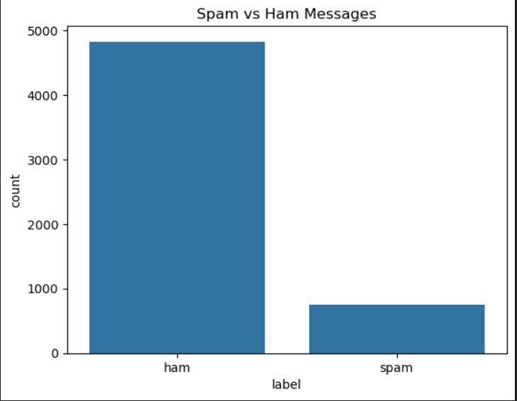

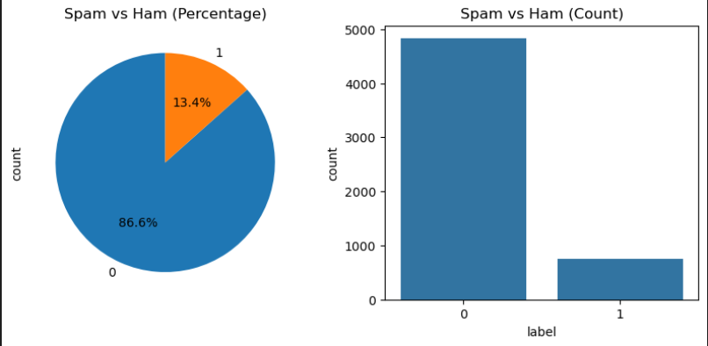

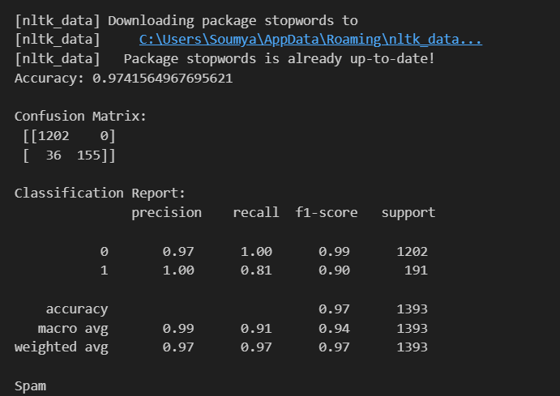

Key Insights :
- The dataset is highly imbalanced, with non-spam (ham) emails making up approximately 86.6% of the data, while spam emails account for only 13.4%, indicating a real-world email distribution pattern.
- Exploratory analysis shows that ham messages significantly outnumber spam messages, which highlights the importance of using appropriate evaluation metrics beyond accuracy.
- The trained NLP-based classification model achieved a high overall accuracy of 97.4%, demonstrating strong performance in distinguishing spam from non-spam emails.
- The confusion matrix indicates that most ham emails were correctly classified, with very few misclassifications.
- Precision for spam emails is 1.00, meaning that emails predicted as spam were almost always truly spam, reducing the risk of incorrectly filtering important emails.
- Although spam recall is slightly lower (0.81), the overall F1-score remains high, showing a good balance between precision and recall in spam detection.

- Model Comparison : The performance of different classification models was compared using evaluation metrics such as Accuracy, Precision, Recall, and F1-score.Models trained with TF-IDF features consistently performed better than those using Bag-of-Words representations.The inclusion of n-grams improved performance by capturing word context and common spam phrases.Among the classifiers, Logistic Regression and SVM showed higher accuracy and balanced F1-scores.Naive Bayes performed efficiently but was slightly less accurate for complex text patterns.Overall, TF-IDF with n-grams combined with advanced classifiers produced the best results for spam detection.

GitHub Repository:
- Description : A GitHub repository has been created to store and manage all files related to this project. The repository contains the source code for Email Spam Classification using NLP, along with project documentation and supporting resources. Using GitHub helps in maintaining version control, organizing the project structure, and sharing the work easily for review and future enhancements.

You can visit to my github account and check for the information needed from my project .

https://github.com/soumya2246/datascience-_project-

Conclusion :

This project focuses on solving the real-world problem of email spam detection by using Natural Language Processing (NLP) and machine learning techniques. Throughout the project, various stages of a data science workflow were followed, including data understanding, text preprocessing, feature extraction, model building, and performance evaluation. These steps helped in transforming raw, unstructured email text into meaningful information that can be used for automated classification.

Text preprocessing techniques such as tokenization, stopword removal, and text normalization played a crucial role in improving the quality of the input data. The use of TF-IDF for feature extraction enabled the model to identify important words that are more relevant for distinguishing spam emails from legitimate ones. Based on these features, the machine learning model was trained to learn patterns present in spam and non-spam emails.

The results obtained from the model evaluation show that NLP-based approaches are effective and reliable for email spam classification. This project demonstrates how Data Analytics helps in understanding data patterns, Data Science integrates preprocessing and modeling, and Artificial Intelligence enables systems to make intelligent decisions automatically. Overall, this project highlights the importance of NLP-driven spam filtering systems in enhancing email security, reducing unwanted messages, and improving the overall user experience.

Future Scope :

The Email Spam Classification system developed in this project can be further enhanced in several ways. More advanced machine learning algorithms such as Support Vector Machines (SVM), Random Forest, or Deep Learning models like LSTM and Transformers can be used to improve classification accuracy. Incorporating techniques such as word embeddings (Word2Vec, GloVe) can help the model better understand the semantic meaning of words.

The project can also be extended by developing a real-time spam detection web application using frameworks like Flask or Streamlit, allowing users to check emails instantly. Additionally, the model can be trained on larger and more diverse datasets to handle evolving spam patterns. Implementing continuous learning and feedback mechanisms will further improve the system’s performance, making it more robust, scalable, and suitable for real-world deployment.
References :
https://ijarst.in/public/uploads/paper/535811743668715.pdf
https://ijcsm.researchcommons.org/cgi/viewcontent.cgi?article=1236&context=ijcsm#:~:text=Beyond%20mere%20nuisance%2C%20spam%20enables,spam%20%5B6%2C%207%5D.
https://ijsrcseit.com/index.php/home/article/view/CSEIT2410220#:~:text=Abstract,R.
https://www.researchgate.net/publication/354177708_Survey_on_Email_Spam_Classification_using_Different_Classification_Method#:~:text=The%20mail%20message%20features%20are,other%20related%20spam%20filtering%20algorithms.&text=Spam%20is%20considered%20a%20significant,and%20false%20negative%20rates%2C%20respectively.
https://www.scribd.com/presentation/895596902/SPAM-EMAIL-CLASSIFIER

